NAME-SATYAM KUMAR JHA SEC-K1, ROLL NO- 2122630050

Q-1 write a c program to cheak whether the given number is palindrome number or not.

Ans:- #include<stdio.h>

#include<conio.h>

Int main()

{

Int n,r,sum=0,temp;

Clrscr();

Printf(“enter a number”);

Scanf(“%d”,&n);

Temp=n;

While(n>0)

{

r=n%10;

sum=(sum\*10)+r;

n=n/10;

}

If(temp==sum)

Printf(“palindrome number “);

Else

Printf(“not a palindrome number”);

Getch();

} 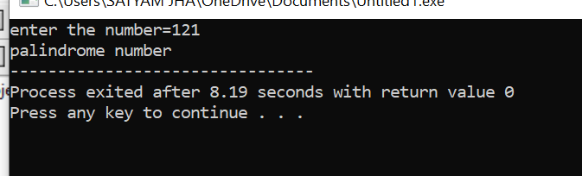

Q-2 write a c program to cheak weather the given number is krishnamurty number/ strong number/Peterson number or not

ANS:-

#include < stdio.h >

int main()

{

int num, temp, rem, count, fact, sum = 0;

printf("Enter a number\n");

scanf("%d", &num);

temp = num;

while(num)

{

rem = num % 10;

count = 1;

fact = 1;

while(count <= rem)

{

fact = fact \* count;

count++;

}

printf("Factorial of %d is %d\n", rem, fact);

sum = sum + fact;

num = num / 10;

}

if(temp == sum)

{

printf("%d is a strong number\n", temp);

}

else

{

printf("%d is not a strong number\n", temp);

}

return 0;

}

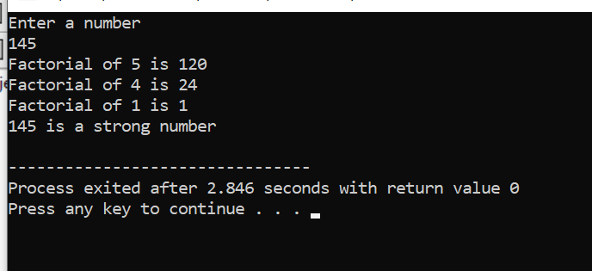

Q-3 write a c program to print the following series.

1

01

010

1010

ANS:-

#include<stdio.h>

#include<conio.h>

void main()

{

int i,j,k=1;

for(i=1;i<=5;i++)

{

for(j=1;j<=i;j++)

{

if(k%2==0)

{

printf("0");

}

else

{

printf("1");

}

k++;

}

printf("\n");

}

getch();

}

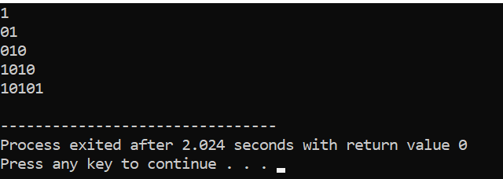

Q 4:- write a c program to print the following series

\*

\* \*

\* \* \*

\* \* \* \*

ANS:-

#include <stdio.h>

#include <conio.h>

int main()

{

int i,j,k,t=0;

for (i=1; i<=5; i++) {

for (k=t; k<5; k++) {

printf(" ");

}

for (j=0; j< i; j++) {

printf(" \* ");

t = t + 1;

}

printf("\n");

}

return 0;

}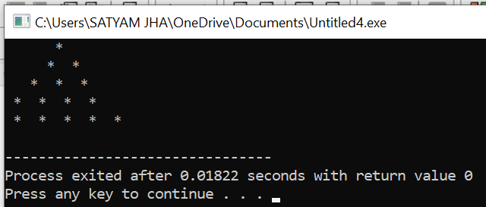

Q – 5 write a c program to print the sum of the following series

1+(1+2)+(1+2+3)+……+(1+2+3+…..+n)

ANS:-

#include<stdio.h>

main()

{

int i=1,n,sum=0,j=1,add=0;

clrscr();

printf("Enter n :\n");

scanf("%d",&n);

i=n;

n=1;

while(i>=n)

{

j=1;

add=0;

while(j<=n)

{

add=add+j;

j++;

}

sum=sum + add;

n++;

}

printf("Result :\n%d",sum);

getch();

}

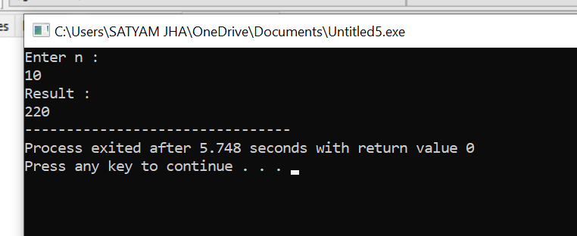

Q-6 write a c program to print integers from 1 to n omiting the integers in divisible by 10.

Ans:-

#include <stdio.h>

int main()

{

int n,i=1;

printf("Enter n :\n");

scanf("%d",&n);

while(i<=n)

{

if(i%10!=0)

printf("%d\n",i);

else

printf("\nDivisible by 10\n");

i++;

}

return 0;

}

